**Making a OnPrintShop Business card with CopyExpress pricing**

Login and go to Products Module and click on the create product button on the top right corner to create a product and it will take us to add product page.

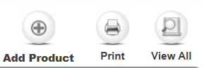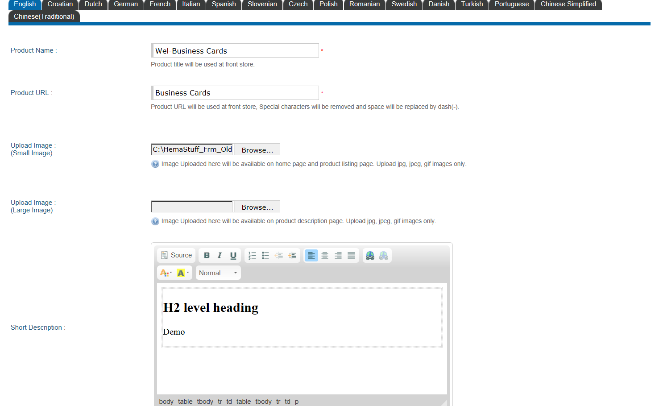

Select range based with multiplication for Pricing Deigning method.

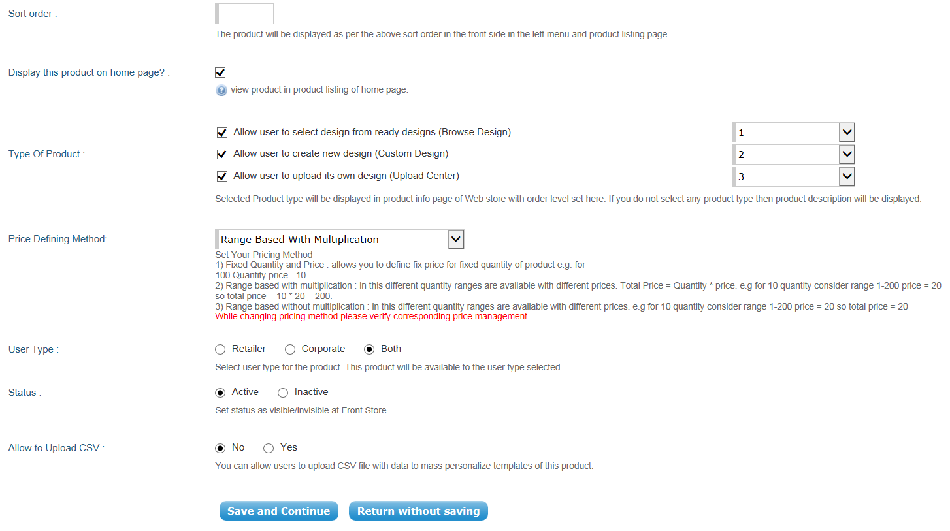

Click Save and Continue to set the price.

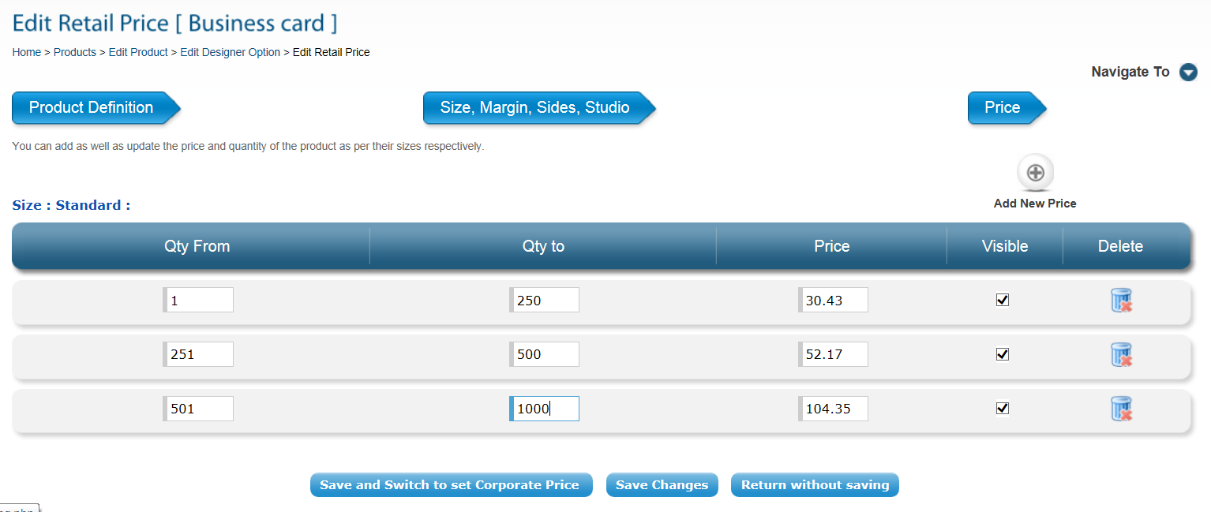

Once entered the price for retail customers, click Save and switch to set Corporate Price as well.

Here I chose to proceed further without entering any price for corporate customers. Entering meta tags for Optimization.

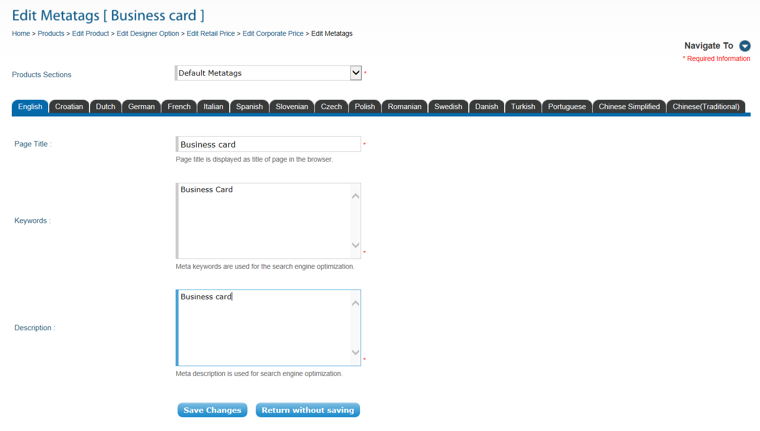

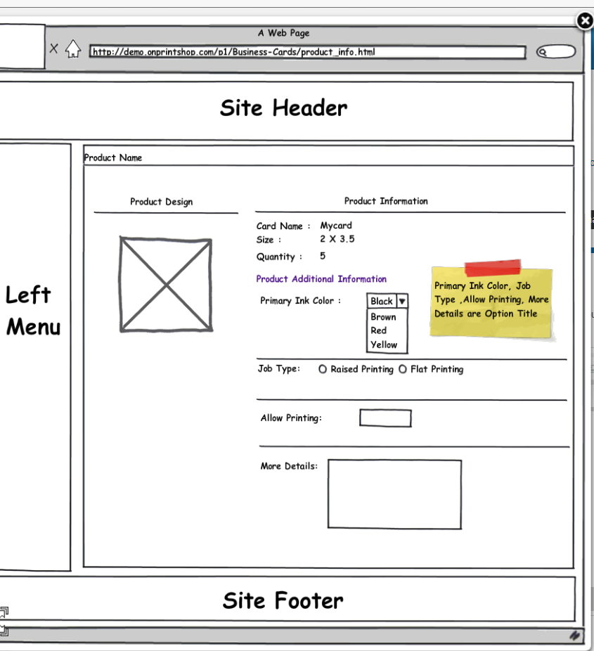

Onc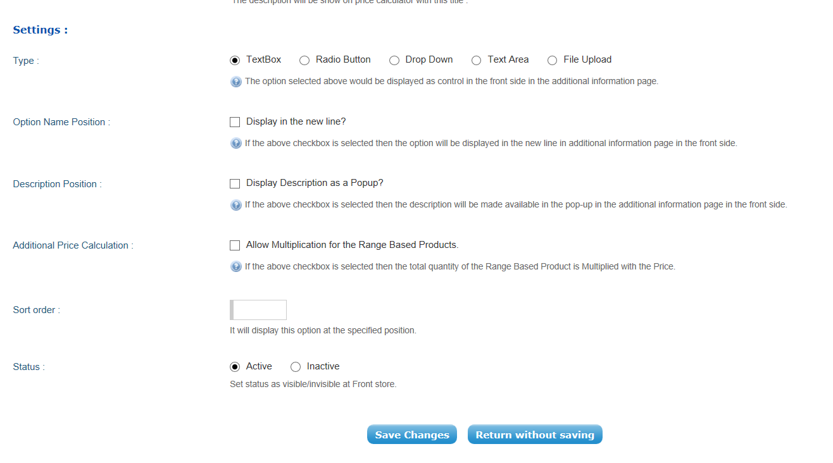

Once the options have been set up Click Save Changes

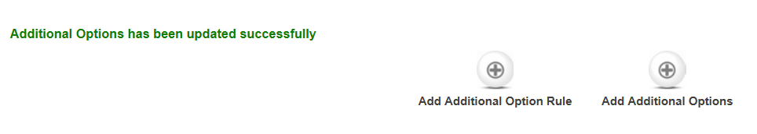

Set additional options and click save to continue.

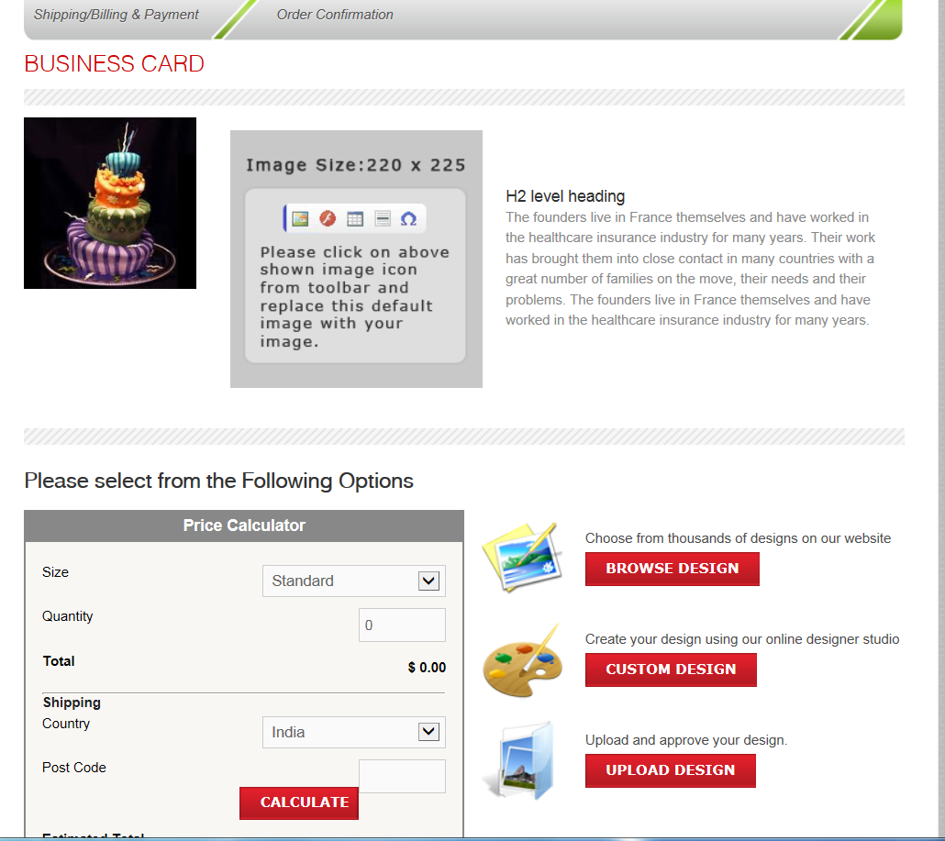

**Price Testing from A4 flyer**

|  |  |  |
| --- | --- | --- |
| **Quantity Ordered** | **Price from Copy Express calculations** | **Result** |
| 100 | $82.40 |  |
| 200 | $118.80 |  |
| 250 | $137.00 |  |
| 251 | $137.36 |  |
| 300 | $155.20 |  |
| 400 | $191.60 |  |
| 500 | $228.00 |  |
| 750 | $299.00 |  |
| 1000 | $370.00 |  |

Part 2

Creating a product for only corporate

